**Inversion Options File**

The information provided by an ER survey is typically insufficient to uniquely determine the subsurface bulk conductivity distribution at the scale of the computational mesh. In order to produce a reasonable representation of the true subsurface conductivity, the inverse solution must be constrained by a priori information in addition to the information provided by the data. The information provided by the data is given implicitly in the survey file. The a priori solution constraints are provided in the inverse options file.

Often, the quality of the inverse solution is highly dependent upon the solution constraints supplied to the inversion algorithm. It is generally beneficial to provide as much information as possible to the inversion algorithm, which can provide marked improvements in imaging resolution. To this end, E4D is implemented with a flexible set of model constraints applied using the method of IRLS. The inversion option file provides E4D with solution constraints zone by zone, and tells E4D how those constraints should be implemented across zone boundaries. Each constraint is specified by two equations, a structural metric and a weighting function. The structural metric provides the constraint equation that, when minimized, imposes a particular structure in the conductivity distribution. The weighting function determines when, and how strongly, the structural metric should be imposed. As described below, E4D currently provides ten structural metrics and four weighting functions. Each is referenced by a unique integer value as shown in the forthcoming structural metric and weighting function tables. The general format of the inverse options is file is shown below.

| **Variable** | **Type** | **Description** |
| --- | --- | --- |
| *n_reg_blocks* | integer | Specifies the number of constraint blocks. A constraint block describes the solution constraints to be applied to a particular mesh zone. Each zone in the mesh should be supplied with at least one constraint block. |
| *zone* | integer | Specifies the zone number to which this constraint block applies.  **This is the beginning of a constraint block.** |
| *s_met wx wy wz* | see  description | *s_met* is an integer that indicates which structural metric to use for this constraint (see structural metric codes below).  *wx wy* and *wz* are positive real values indicating the relative weighting of this structural metric in the x, y, and z directions respectively.  Note: *wx, wy*, and *wz* are not used by every structural metric. In cases where they are not used, they are ignored by E4D in the inversion. However, they must be present in the inverse options file, regardless of which structural metric is used. |
| *fw mn sd* | see  description | *fw* is an integer value indicating which re-weighting function to use with this structural metric (see weighting function codes below).  *mn* is a real value indicating the mean of the re-weighting function  *sd* is a real value indicating the standard deviation of the weighting function |
| *n_links l1 l2 ... ln_links* | integer | *n_links* is the number of zones to which this zone is linked.  *l1 l2* ... *ln_links* are the zone numbers to which this zone is linked.  Elements bounding the zone constrained by this block will be connected to this block (through the regularization constraints specified in this block) if the zones to which those elements belong are specified in the link list.  A zone may not be linked to itself. In other words, each of the linked zones *l1 l2* ... *ln_links* listed must be different from the variable *zone*. |
| *v_ref* | see  description | *v_ref* specifies the reference value used for this constraint block. If *v_ref* is a real number, then *v_ref* is used as the reference value. If *v_ref* is specified as "*REF*" or "*Ref*" or "*ref*", then the reference model specified in *e4d.inp* is used to provide the reference values for each element in the zone constrained by this block.  Not all structural metrics use a reference value. However, *v_ref* must always be specified in the inverse options file. If *v_ref* is not used by the structural metric specified by this constraint block, then it is ignored by E4D.  Note: in mode 4, v_ref may also be specified as “PREF”, “Pref”, or “pref”, in which case the solution to the previous time-lapse inversion is used as the reference model for this block. |
| *w_rel* | real | *w_rel* is the relative weight applied to this constraint block. This parameter provides the capability to enforce some constraints more strongly than others.  A value of 1.0 will suffice for most problems.  **This is the end of a constraint block. There must be** *n_reg_blocks* **constraint blocks specified in the inversion options file.** |
| *beta min_red beta_red* | real | *beta* is the global constraint weighting value at the beginning of the inversion, and controls the importance the inversion places on enforcing the model constraints in comparison to fitting the data.This parameter is either held constant or automatically reduced (see *up_opt* below) by E4D during the inversion when required to reduce the misfit between measured and simulated data. (see the *E4D* theory guide)  *min_red* is the minimum fractional decrease in the objective function between outer iterations that may occur before *beta* is reduced (see *E4D* theory guide). A conservative value for *min_red* is 0.05. Larger values of *min_red* will generally decrease time to convergence, but may also provide solutions that violate the model constraints more than what is necessary to appropriately fit the data.  *beta_red* is the *beta* reduction factor. If the fractional decrease in the objective function between outer iterations is less than or equal to *min_beta*, then *beta* is reduced by a factor of *beta_red* for the next iteration*.* A conservative value for *beta_red* is 0.5. |
| *chi_target* | real | *chi_target* is the normalized chi-squared value at which the inversion is considered to have converged. In the absence of modeling errors and accurately specified data standard deviations, *chi_target* should reach a value of 1.0 at convergence.  (see *E4D* theory guide) |
| *miniter maxiter* | integer | *miniter* is the minimum number of inner iterations (i.e. CGLS iterations) to execute before updating the solution (see E4D design guide, recommended value = 30)  *maxiter* is the maximum number of inner iterations to execute before updating the solution (recommend value = 50) (see *E4D* design guide) |
| *min_sig max_sig* | real | *min_sig* and *max_sig* are respectively minimum and maximum conductivity values allowed by the inversion. Note that these values do not constrain the inversion, and are provided only  as a safety mechanism to ensure the forward solutions remain stable. Maximum and minimum conductivity constraints can, and should, be specified as model constraints within the constraint block section of the inversion options file when necessary. |
| *up_opt* | integer | If *up_opt* = 1 a line search to estimate the optimum *beta* value is executed  if *up_opt* = 2, no line search is executed and beta reduces as specified by *min_red* and beta_red  if *up_opt = 3,* beta remains at its starting value, and the inversion converges when the reduction in the objective function is less than *min_red* or the target chi-squared value is reached,  whichever comes first.  **The beta line search has not been quality tested, therefore E4D defaults to up_opt = 2 when up_opt = 1 is specified.** |
| *n_sfacs* | integer | Specifies the number of line search scaling factors to test in order to estimate the optimal scaling factor. If *up_opt*=2, this value is not used by E4D, and should not be included in the inverse options file. |
| *sfac1 ... sfac_n_sfacs* | real | Line search scale factors to test during the line search. If up_opt = 2, these values are not used by E4D, and should not be included in the inverse file. |
| *cflag cdev* | see description | *cflag* is an integer value of 0 or 1. If *clag* = 1 then data outlier re-weighting is implemented. If *cflag* = 0 then all data will be used to constrain the inversion at every iteration.  *cdev* is a positive real value specifying the outlier removal standard deviation. If the weighted residual error of any datum is greater than *cdev* standard deviations from the mean weighted residual error and *cflag* = 1, then that datum is not used to constrain the inversion in next iteration. (Recommended value = 3)  Outlier conditions are checked at every iteration, so a particular datum may be removed for one iteration and included in the next, and vice-versa. |

**Structural Metric Codes**

A structural metric is defined herein as an equation describing a relationship between the conductivity of a target element and 1) the conductivity of the target elements neighbor, 2) a specified reference conductivity value (see *v_ref* in the inverse options file format above), or 3) the conductivity of the corresponding element specified in the reference model file. When a particular structural metric is specified to a zone, E4D applies that metric to every element in that zone, and optionally to elements bounding that zone if so specified in the corresponding constraint block. E4D attempts to minimize each structural metric, which imposes some desired structure in the inverse solution (see *E4D* theory guide). E4D determines the conditions under which to apply the constraints according to the weighting function applied to each structural metric. Thus the behavior of each structural metric in terms of constraining the inversion is also dependent upon the corresponding weighting function for that metric. In the table below, we provide the equations defining each structural metric. In the next section, we provide the weighting functions, and follow-up with several examples of how structure metric/weighting function combinations can be used to provide the inversion with information concerning the subsurface conductivity structure.

|  |  |
| --- | --- |
| **Structure metric code (*s_met*)** | **Equation** |
| 1 | X = mt - mn |
| 2 | X = |mt - mn| |
| 3 | X = mt - *v_reft* |
| 4 | X = |mt - *v_reft|* |
| 5 | X = mt - mn (with anistropic weighting) |
| 6 | X = |mt - mn| (with anistropic weighting) |
| 7 | X = (mt - *v_reft*) - (mn - *v_refn*)  X = Dmt - Dmn |
| 8 | X = |(mt - *v_reft*) - (mn - *v_refn*)|  X = |Dmt - Dmn| |
| 9 | X = mt - mn (applied only at specified boundaries) |
| 10 | X = |mt - m n| (applied only at specified boundaries) |
| Variables: X = value of the structural metric, and the independent variable in each weighting function. mt = log conductivity of the target element mn = log conductivity of the target elements neighbor v_reft = log conductivity of the target elements reference value, taken from either the constraint block or converted from the reference model file v_refn = log conductivity of neighbors reference value, taken from either the constraint block or converted from the reference model file Dmt = change in log conductivity of target element with respect to v_reft Dmn = change in log conductivity of neighbor element with respect to v_refn | |

**Weighting Function Codes**

The primary purpose of the weighting function is to determine the conditions under which the corresponding structural metric should or should not be used to constrain the inversion. In essence, the weighting functions turn the structural metrics on and off, and determine how much weight should be placed on minimizing the structural metric in the transition between on and off. The independent variable for each weighting function is the value of the structural metric (i.e., the value X in the structural metric code table above). Each of the four weighting functions is based on the normal and cumulative normal distribution functions, and ranges between 0 and 1. If the weighting function evaluates to zero, then the structural metric is inactive and plays no role in constraining the inversion. If it evaluates to one, then the structural metric is fully active. The following table and figures show the equation and form of each weighting function.

|  |  |
| --- | --- |
| **Code** | **Equation** |
| 1 | Wf=.5(1- erf( (X-*mn*) / sqrt(2\**sd2*) ) )  (see Figure 1) |
| 2 | Wf=.5(1- erf( (X+*mn*) / sqrt(2\**sd2*) ) )  (see Figure 2) |
| 3 | Wf=1-exp(-((X-*mn*)2) / (2\**sd*2) ) (see Figure 3) |
| 4 | Wf=exp(-((X-*mn*)2) / (2\**sd*2) )  (see Figure 4) |
| Variables: Wf = value of the weighting function where (0 <= Wf <= 1) X = value of the structural metric (see structural metric code table above)  erf = error function *mn* = mean of the weighting function as specified in the constraint block (see inversion options file format and Figure 1-4 below). *sd* = standard deviation of the weighting function as specified in the constraint block (see inversion options file format and Figure 1-4 below). | |

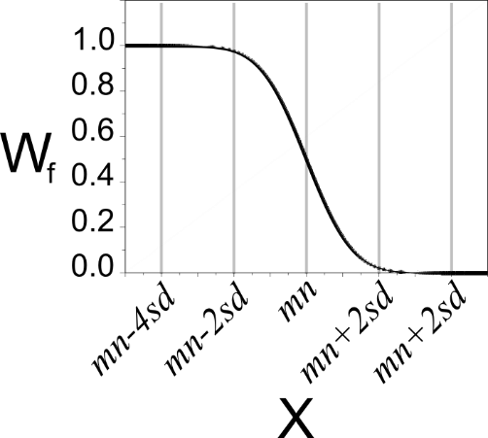

**Figure 1.** Weighting function 1 causes E4D to minimize X if X drops below *mn+2sd*, reaching full weight if X drops below *mn-2sd*.

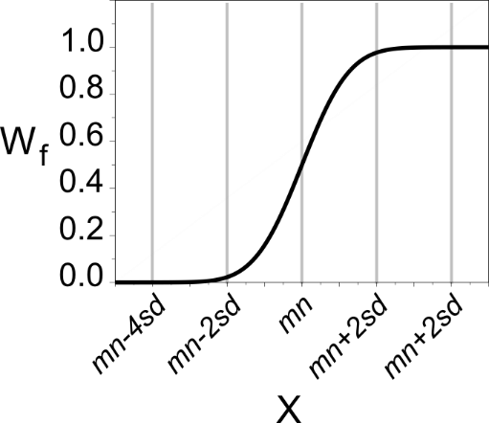

**Figure 2.**Weighting function 2 causes E4D to begin to minimize X if the value of X rises above *mn-2sd*, reaching full weight if X rises above *mn+2sd*.

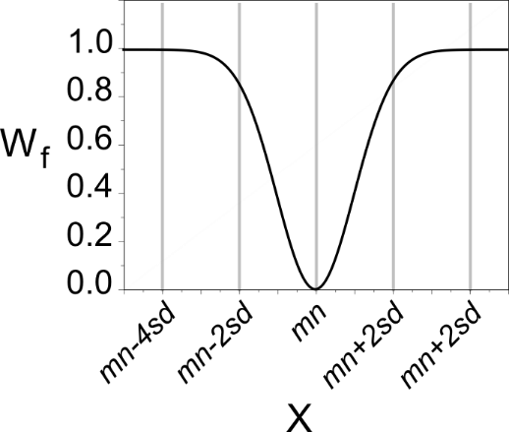

**Figure 3.**Weighting function 3 causes E4D to begin to minimize X if the value of X deviates from mn, reaching full weight if X deviates from mn by more than (approximately) 2sd.

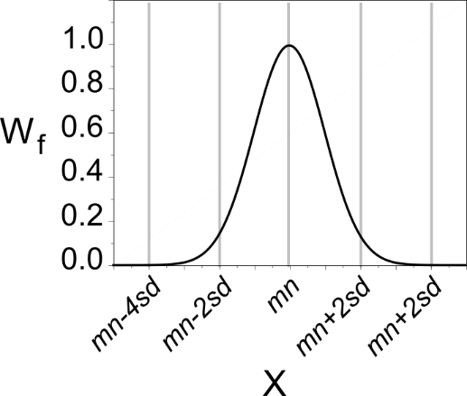

**Figure 4.**Weighting function 4 causes E4D to begin to minimize X as the values of X approaches mn, reaching full weight when X is equal to mn.

**Example Constraints for Static Inversions**

The combination of structural metric, weighting function, and custom mesh generation (i.e., incorporation of known conductivity boundaries) capabilities are intended to provide flexibility and creativity in applying solution constraints within E4D. The examples below show how structural metrics, weighting functions, and zone boundaries work together to inform E4D concerning known subsurface conductivity conditions. They do not present all of the possible constraint combinations, but are intended to provide users with enough familiarity to formulate their own problem specific constraints. It is important to note that similar constraints can often be implemented with different pairs of structural metrics and weighting functions.

**Smoothness Constrained Inversion**

Standard smoothness constraints are implemented by encouraging the inversion to enforce similarity between neighboring elements. For reasons that will become evident in the next example, we recommend using structural metric 2 and weighting function 1 (with a large mean value) to enforce smoothing constraints. Structural metric 1 increases as the absolute difference between the log conductivity of each element and its neighbor increases. Combined with structural metric 2, weighting function 1 will encourage the inversion to minimize the absolute log conductivity difference with full weight as long as that difference is greater than approximately *mn-2*sd*. If *mn* is larger than any reasonably expected absolute difference between any two elements, and *sd* is small, then weighting function 2 will apply full weight at each iteration. As described in the E4D theory guide, this is equivalent to standard L2-norm regularization weighting (e.g., Tikhonov regularization).

For example, suppose we have a mesh with three zones. Zone 2 has boundaries adjacent to both zones 1 and 3. We wish to constrain zone 2 with smoothness constraints, including smoothness constraints across the boundaries with zones 1 and 3. A constraint block that fulfills these requirements is given by:

**<begin constraint block>**  this line is not included in the inverse options file

2 this is the zone number constrained by this block  
2 1.0 1.0 1.0 use structural metric 2, (x,y,z weighting values are not used with 2)   
1 10 0.001 use weighting function 1 with mean = 10 and st. dev. of 0.001.   
2 1 3 apply the constraints across boundaries with zone 1 and 3  
0.0 this is the reference value, which is not used by structure metric 2  
1.0 this is the relative weight for this structure metric.

**<end constraint block>** this line is not included in the inverse options file

**Smoothing with Sharp Boundaries (Blocky Inversion)**

Several methods have been proposed that enable inversions to provide solutions with sharp internal boundaries. In general, most of these approaches are implemented by reducing the similarity constraints between neighboring elements as the difference in conductivity between those elements increases. This enables a 'fracture' to develop between elements that exhibit a relatively large difference in conductivity, and enables elements on either side of the 'fracture' to become similar, thereby providing a compact or blocky conductivity image. Such constraints can be implemented in E4D using the same constraint block described above for smoothness constrained inversions, but with a smaller mean in the weighting function. By doing so, the similarity constraint between neighboring elements is removed as the conductivity difference between those elements increases, depending on the values of *mn* and *sd* characterizing the weighting function. For example, consider the constraint block below.

**<begin constraint block>** this line is not included in the inverse options file

2 this is the zone number constrained by this block  
2 1.0 1.0 1.0 use structural metric 2, x,y,z weighting values are not used with 2  
1 .5 0.01 use weighting function 1 with a mean = 0.5 and st. dev. = 0.01.   
2 1 3 apply the constraints across 2 boundaries with zones 1 and 3   
0.0 this is the reference value, which is not used by structure metric 2  
1.0 this is the relative weight for this structure metric.

**<end constraint block>**

This constraint block will enforce similarity between neighboring elements as long as the absolute difference in log conductivity is less than 0.5-0.01. When the log conductivity difference between two elements exceeds 0.5-0.01, E4D will begin to reduce the similarity constraints between those elements, enabling the difference between them to further increase. If the log conductivity difference exceeds 0.5+.001, then the similarity constraints between those elements are removed in the next iteration, enabling the inversion to place a sharp contrast at the boundary without penalty. As described in the E4D theory guide, commonly used weighting functions published in the literature (e.g., compactness constraints and ln-norm) can be closely approximated by modifying *mn*, *sd*, and *w_rel* (the relative weight) for each constraint block.

**Minimum Conductivity**

Reasonable limits on the minimum and maximum subsurface conductivity are often available for a given application. Inequality constraints, which enforce conductivity limits, can provide a valuable source of information to the inversion algorithm and significantly improve imaging resolution. Minimum conductivity constraints can be implemented in E4D using structural metric 3 and weighting function 1.

Structural metric 3 provides the relative difference between the log conductivity of each element and the log conductivity of a corresponding reference value, which is provided in the constraint block or computed from the values in the reference conductivity file. E4D minimizes structural metric 3 by moving the log conductivity of each element toward its reference value.

The minimum conductivity constraint is applied by instructing E4D to enforce the condition that the log conductivity of each element is always greater than or equal to the reference value. Using structural metric 3, this is accomplished by applying weighting function 1 with a mean of 0 and a relatively small standard deviation. For example, suppose zone 3 of a given mesh represents a body of surface water, and it is known the conductivity of the water is (depending on temperature) always greater than 0.01 S/m. A constraint block enforcing this condition is shown below.

**<begin constraint block>** this line is not included in the inverse options file

3 this is the zone number constrained by this block  
3 1.0 1.0 1.0 use structural metric 3, x,y,z weighting values are not used  
1 0 0.05 use weighting function 1 with a mean = 0.0 and st. dev. = 0.05   
0 do not apply this constraint across any boundaries  
-4.61 this is the reference value, (i.e. log(0.01))  
1.0 this is the relative weight for this structure metric.

**<end constraint block>**

The weighting function in this case provides full weight toward minimizing the structural metric if the structural metric drops below approximately *mn*-2\**sd* = 0.0 - 2*(0.05) = -0.10. In other words, E4D will apply full weight toward moving the log conductivity to the reference value (thereby minimizing the structural metric), of any element whose log conductivity drops 0.10 S/m below the reference value. As the log conductivity increases, the weighting function will apply less weight toward minimizing the structural metric, until the constraint is removed (i.e. the weighting function is zero) at approximatey X=*mn*+2*sd* = 0.10 S/m, which means the log conductivity of the element is -4.61 + 0.10 s/m = -4.51 S/m.

**Maximum Conductivity**

Maximum conductivity constraints may be applied similarly to minimum conductivity constraints, except that weighting function 2 is used instead of weighting function 1. For example, suppose zone 3 of a given mesh represents a body of surface water, and it is known the conductivity of the water is (depending on temperature) always less than 0.01 S/m. A constraint block enforcing this condition is shown below.

**<begin constraint block>** this line is not included in the inverse options file

3 this is the zone number constrained by this block  
3 1.0 1.0 1.0 use structural metric 3, the x,y,z weighting values are not used with 3  
2 0 0.05 use weighting function 1 with mean = 0.5 and st. dev. of 0.001.   
0 do not apply this constraint across any boundaries  
-4.61 this is the reference value, (i.e. log(0.01))  
1.0 this is the relative weight for this structure metric.

**<end constraint block>**

**Known Value with Uncertainty**

In some cases the bulk conductivity of the subsurface represented by a mesh zone may be known with some degree of certainty. Such information can be provided to E4D using structural metric 3 or 4 with weighting function 3, using a mean of zero and a standard deviation that represents the uncertainty in the reference conductivity value. In a manner analogous to the minimum and maximum conductivity constraints discussed above, weighting function 3 (with structural metric 3 or 4) will cause the inversion algorithm to move the log conductivity of an element toward the reference value with increasing weight as the deviation from the reference value increases, reaching maximum weight when the absolute value of the deviation reaches *mn*+2\**sd* = 2\**sd.*